HOSTE D BY

Available online at [www.sciencedirect.com](http://www.sciencedirect.com/science/journal/2314808X)

ScienceDirect

journal homepage: <http://ees.elsevier.com/ejbas/default.asp>

[e g ypti an j o ur nal o f b a sic and a pp l i e d sci en c e s 2 ( 201 5 ) 8 7](http://dx.doi.org/10.1016/j.ejbas.2015.02.001) e[9](http://dx.doi.org/10.1016/j.ejbas.2015.02.001) 7



Biohazards of the biofungicide, *Trichoderma harzianum* on the crayfish, *Procambarus clarkii*: Histological and biochemical implications

*Sherin K. Sheir*\**, Gamalat Y. Osman, Mansour A. Galal, Mona M. Soliman*



*Department of Zoology, Menoufia University, Shebeen El-koom, Egypt*

## a r t i c l e i n f o

*Article history:*

Received 25 October 2014 Received in revised form 28 January 2015

Accepted 1 February 2015

Available online 20 February 2015

*Keywords:* Crayfish Biofungicide Histopathology Gonads

Protein density

## a b s t r a c t

Pesticides are one of the pollutants threatening aquatic invertebrates living in the tribu- taries of the River Nile. So, the effect of the biofungicide, *Trichoderma harzianum* on the crayfish, *Procambarus clarkii* and its influence on electrophretic pattern of proteins and tissue pathology of gonads were studied. Different concentrations of *T. harzianum* (100, 50, 40, and 20%) were used. The potency of *T. harzianum* to genocide ranged from many hours (less than a day) with 100% concentration to 39 day of treated with 20% concentration. Electrophoretic analysis was done to compare protein patterns of muscles from control and treated animals with 20% *T. harzianum*. The result recorded decrease in protein density of males and females post exposure to *T. harzianum* after one week (this decrease was more in males than females). However, the protein density increased four weeks post exposure to *T. harzianum* (this increase was more in females than in males). *T. harzianum* caused some histobathological changes in testis after four weeks post exposure when compared to the control. The testis showed deformed architecture, some testicular acini showed incomplete fusion and others with elongated shape. On the other hand, the ovary exhibited severe damage in oogenetic pouch like detachment of ovarian epithelium, fusion between some oogenetic pouches, and necrosis in connective tissue. It can be concluded that, *T. harzianum* has deleterious effects on the proteins and gonads of *P. clarkii* that may lead to disturbance/decrease in productivity and even death to this organism and the surrounding environment.

Copyright 2015, Mansoura University. Production and hosting by Elsevier B.V. This is an open access article under the CC BY-NC-ND license ([http://creativecommons.org/licenses/](http://creativecommons.org/licenses/by-nc-nd/4.„0/)

[by-nc-nd/4.0/](http://creativecommons.org/licenses/by-nc-nd/4.„0/)).

# Introduction

River Nile is considered as one of the most important rivers in the world. It is the major water source in Egypt and is there- fore subjected to multiple uses. Due to human activities of

various kinds along its course such as domestic, commercial, agricultural, industrial, navigation, and invasive activities of certain new animals, its water quality was negatively influ- enced. Huner and Linqvist [1] added that, *Procambarus clarkii* had been introduced into many other countries all over the world due to its highly tolerance to the unfavorable conditions

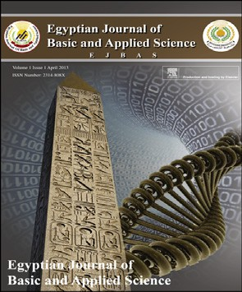

* *Corresponding author*.

E-mail address: [sherin.sheir@yahoo.com](mailto:sherin.sheir@yahoo.com) (S.K. Sheir).

Peer review under responsibility of Mansoura University. <http://dx.doi.org/10.1016/j.ejbas.2015.02.001>

2314-808X/Copyright 2015, Mansoura University. Production and hosting by Elsevier B.V. This is an open access article under the CC BY- NC-ND license ([http://creativecommons.org/licenses/by-nc-nd/4.0/](http://creativecommons.org/licenses/by-nc-nd/4.„0/)).

88 [e gypti an j o ur nal o f b a sic and a pp l i ed sci e n c e s 2 ( 201 5 ) 8 7](http://dx.doi.org/10.1016/j.ejbas.2015.02.001) e[9](http://dx.doi.org/10.1016/j.ejbas.2015.02.001) 7

|  |  |  |  |  |  |  |  |
| --- | --- | --- | --- | --- | --- | --- | --- |
| Table 1 e Tolerance effect of different concentrations of *T. harzianum* on *P. clarkii*. | | | | | | | |
| Periods | Conc. | | | | | | |
| % Mortality of *P. clarkii* after six weeks of the Experiment | | | | | |  |
| Con | trol | 20% | 40% | 50% | 100% | |
| 1st week | 0% |  | 0% | 40% | 50% | 100% | |
| 2nd week | 0% |  | 0% | 50% | 50% | e | |
| 3rd week | 0% |  | 20% | 50% | 50% | e | |
| 4th week | 0% |  | 40% | 60% | 100% | e | |
| 5th week | 0% |  | 80% | 100% | e | e | |
| 6th week | 0% |  | 100% | e | e | e | |
| Survival | 42 | days | 39 days | 28 days | 26 days | 20 h | |
| period |  |  |  |  |  |  | |

such as poor water quality, temperature fluctuations, low oxygen concentrations and desiccation beside its extraordi- nary production rate in farming. The red swamp crayfish, *P. clarkii*, is an autochthonous species from the Northeast of Mexico and South Central USA [2], which was introduced worldwide and has become the dominant freshwater crayfish in almost all areas it occupied [3]. It accounts for at least 80% of all wild and cultured crayfish harvested around the world [4]. Over 60,000 tons of *P. clarkii* was produced annually in the USA and China [5].

The initial access and colonization of *P. clarkii* started a commercial aquaculture in Giza (Manial- Sheiha), in the early 1980's, when the first immigrants of this species were intro-

duced from USA. The majority of introductions of these cray-

fishes had negative consequences [6]. The ecological surveys indicated that the crayfish had flourished and widely spread all

over most of the River Nile and its tributaries and also in some of the newly inhabited areas in Egypt; reaching to some ditches in Sinai desert through the irrigation system. The range of the crayfish populations had clearly expanded northwards since the middle of 1980s until Damietta and Rashid and southward up to Aswan. Generally, they appeared relatively more abun- dant in Qalyoubiya, Cairo and Giza governorates than in EL- Menoufiya and EL-Sharkyia. In Giza governorate, crayfishes were frequently reported in the main Nile and in Ibrahimia Canal. All water courses in this governorate near to Nahia, Warrak EL-Arab, Abou- Rawash region, EL-Zumur and EL- Maryouteya canals were variably populated with the crayfish [7]. Studies of their natural habitats in Louisiana showed that *P. clarkii* preferred shallow, eutrophic, slow-moving water or swamps. As a burrower, this species was well-adapted to alternating periods of flooding and receding water levels [8].

Anderson *et al*. [9] stated that crawfish was used as a bio-

indicator of petroleum pollution. Ibrahim *et al*. [10] studied the toxicological impact of the organophosphorus insectside fenthion on *P. clarkii.* They found that LC50 of the fenthion was 1 mg/l after exposure to 12 h. The side effect of this insectcide on *P. clarkii* reduced its activity only at closed aquatic habitats or some fish ponds (not in Nile or its irrigation). Abdel Mageed

[11] proved that heavy metals concentrated inside different tissues of *P. clarkii* collected from the River Nile. In addition, he showed that the chronic exposures to the insecticide Feni- trothion caused histpathological changes in hepatopancreas, testis and ovary of *P. clarkii*. The degree of change in these tissues depended on the time of exposure and the ability of animal to overcome the toxicity of Fenitrothion. Heiba [12] found that, testes of *P. clarkii* sustained severe damage after exposure to the copper sulfate and this degeneration caused

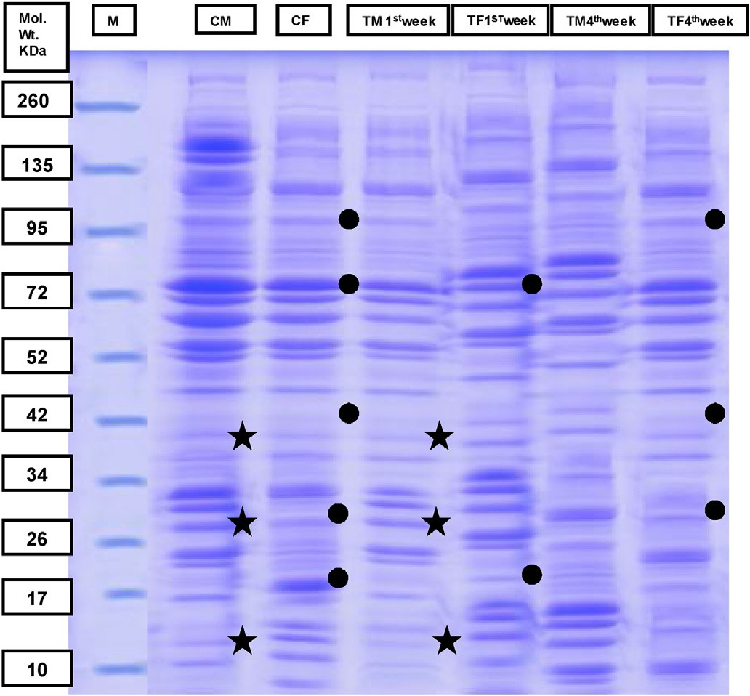

Fig. 1 e Electrophoretic patterns of muscle proteins extracted from control and treated male and female *P. Clarkii* with sub- lethal concentration of *T. harzianum* at the 1st and 4th weeks of exposure. CM: control male, CF: control female, TM 1st week: treated male post one week of exposure, TF1st week: treated female post one week of exposure, TM4th week: treated male post four weeks of exposure, TF4th week: treated female post four weeks of exposure, M: Marker. + and C represent male and female protein bands appearance and disappearance compared to control, respectively.

[e g ypti an j o ur nal o f b a sic and a pp l i e d sci en c e s 2 ( 201 5 ) 8 7](http://dx.doi.org/10.1016/j.ejbas.2015.02.001) e[9](http://dx.doi.org/10.1016/j.ejbas.2015.02.001) 7 89

|  |  |  |  |  |  |  |  |  |  |  |
| --- | --- | --- | --- | --- | --- | --- | --- | --- | --- | --- |
| Table 2 e Electrophoretic patterns of muscles protein extracted from control and treated male and female *P. Clarkii* with Sub-lethal concentration (20%) of *T. harzianum* at the 1st week post exposure. | | | | | | | | | | |
| Band | Marker  Mol.Wt | % | Control animals | | |  | Treated animals (At the 1st week  exposure) | | | post |
| Male | | Female  Mol.Wt | % | Male  Mol.Wt | % | Female  Mol.Wt | % |
| Mol.Wt | % |
| 1 |  |  |  |  |  |  |  |  | 287.47 | 9.01 |
| 2 |  |  |  |  | 280.00 | 4.21 |  |  |  |  |
| 3 |  |  | 278.70 | 2.73 |  |  |  |  |  |  |
| 4 |  |  |  |  |  |  | 275.60 | 3.84 |  |  |
| 5 | 260.00 | 2.98 |  |  |  |  |  |  |  |  |
| 6 |  |  |  |  | 229.51 | 2.64 |  |  |  |  |
| 7 |  |  | 197.38 | 10.60 |  |  |  |  |  |  |
| 8 |  |  |  |  |  |  |  |  | 183.57 | 6.30 |
| 9 |  |  | 180.52 | 2.82 |  |  |  |  |  |  |
| 10 |  |  |  |  |  |  |  |  | 173.45 | 2.26 |
| 11 |  |  | 168.82 | 4.87 |  |  |  |  |  |  |
| 12 |  |  | 158.84 | 10.80 |  |  |  |  |  |  |
| 13 |  |  |  |  | 155.67 | 6.98 |  |  |  |  |
| 14 |  |  | 152.50 | 4.80 |  |  |  |  |  |  |
| 15 |  |  |  |  |  |  | 151.30 | 4.23 |  |  |
| 16 |  |  |  |  |  |  |  |  | 150.71 | 1.87 |
| 17 |  |  |  |  | 147.05 | 4.45 |  |  |  |  |
| 18 | 135.00 | 2.42 |  |  |  |  |  |  |  |  |
| 19 |  |  |  |  | 123.98 | 3.09 |  |  |  |  |
| 20 |  |  |  |  |  |  | 113.85 | 6.42 |  |  |
| 21 |  |  |  |  | 101.27 | 5.93 |  |  |  |  |
| 22 | 95.00 | 3.17 |  |  |  |  |  |  |  |  |
| 23 |  |  |  |  |  |  | 92.12 | 5.64 |  |  |
| 24 |  |  |  |  | 90.71 | 2.21 |  |  |  |  |
| 25 |  |  |  |  | 82.07 | 10.81 | 80.82 | 5.76 | 81.44 | 1.13 |
| 26 | 72.00 | 13.20 |  |  |  |  |  |  |  |  |
| 27 |  |  |  |  |  |  |  |  | 70.67 | 4.77 |
| 28 |  |  |  |  |  |  | 66.22 | 1.08 |  |  |
| 29 |  |  |  |  |  |  |  |  | 62.63 | 3.89 |
| 30 |  |  |  |  | 59.78 | 8.31 |  |  |  |  |
| 31 |  |  |  |  |  |  | 56.54 | 7.59 | 55.50 | 5.90 |
| 32 | 52.00 | 12.50 |  |  |  |  |  |  |  |  |
| 33 |  |  |  |  |  |  | 74.82 | 7.36 | 48.92 | 11.40 |
| 34 | 42.00 | 5.70 | 41.42 | 7.27 | 42.32 | 13.10 | 40.99 | 15.50 |  |  |
| 35 |  |  | 38.55 | 3.30 |  |  |  |  | 37.48 | 7.61 |
| 36 |  |  |  |  | 35.99 | 3.42 |  |  |  |  |
| 37 | 34.00 | 4.99 |  |  |  |  |  |  |  |  |
| 38 |  |  | 31.78 | 12.40 | 32.88 | 2.17 |  |  |  |  |
| 39 |  |  | 29.77 | 6.89 | 29.73 | 2.87 |  |  |  |  |
| 40 | 26.00 | 22.70 | 27.29 | 11.20 |  |  |  |  | 27.25 | 20.60 |
| 41 |  |  |  |  |  |  | 24.34 | 18.70 |  |  |
| 42 |  |  |  |  | 22.35 | 14.90 |  |  | 21.94 | 3.14 |
| 43 |  |  |  |  |  |  | 19.77 | 5.36 | 18.68 | 4.89 |
| 44 | 17.00 | 12.30 |  |  | 17.16 | 14.90 |  |  |  |  |
| 45 |  |  | 15.54 | 10.20 |  |  | 15.64 | 18.30 | 15.67 | 17.20 |
| 46 |  |  | 13.44 | 10.10 |  |  |  |  |  |  |
| 47 | 10.00 | 19.90 | 10.09 | 1.97 |  |  |  |  |  |  |
| No. of bands |  |  | 14 |  | 15 |  | 12 |  | 14 |  |
| Similarity index |  |  |  |  |  |  | 0.154 |  | 0.138 |  |

vacuolazation. In addition, the heavy metals inhibited sper- matogenesis and the irradiation had the same effect on the testis and ovary of *P. clarkii*.

The biocontrol agent, *Trichoderma harzianum* used to con- trol seed rot, and soil borne plant pathogens and plant root diseases caused by pests such as *Pythium, Rhizoctonia,*

*Cylindrocladium, Fusarium and Thielaviopsis* [13]. It also used to improve plant growth and stress tolerance [14].

This study was planned to study the influence of toxic ef- fects of the biofungicide, *T. harzianum* compounds on histol- ogy of gonads in addition to the analysis of proteins in muscles of *P. clarkii*.

90 [e gypti an j o ur nal o f b a sic and a pp l i ed sci e n c e s 2 ( 201 5 ) 8 7](http://dx.doi.org/10.1016/j.ejbas.2015.02.001) e[9](http://dx.doi.org/10.1016/j.ejbas.2015.02.001) 7

|  |  |  |  |  |  |  |  |  |  |  |
| --- | --- | --- | --- | --- | --- | --- | --- | --- | --- | --- |
| Table 3 e Electrophoretic patterns of muscles proteins extracted from control and sub-lethal concentration (20%) of *T. harzianum* at the 4th week post exposure. | | | | | | | treated male and female *P. Clarkii* | | | with |
| Band | Marker  Mol.Wt | % | Control animals | | |  | Treated animals (At the 4th week  exposure) | | | post |
| Male | | Female  Mol.Wt | % | Male  Mol.Wt | % | Female  Mol.Wt | % |
| Mol.Wt | % |
| 1 |  |  |  |  |  |  | 287.70 | 9.74 |  |  |
| 2 |  |  |  |  |  |  |  |  | 282.70 | 4.22 |
| 3 |  |  |  |  | 280.00 | 4.21 |  |  |  |  |
| 4 |  |  | 278.70 | 2.73 |  |  |  |  |  |  |
| 5 | 260.00 | 2.98 |  |  |  |  |  |  |  |  |
| 6 |  |  |  |  | 229.51 | 2.64 |  |  |  |  |
| 7 |  |  | 197.38 | 10.60 |  |  |  |  |  |  |
| 8 |  |  | 180.52 | 2.82 |  |  |  |  |  |  |
| 9 |  |  | 168.82 | 4.87 |  |  |  |  |  |  |
| 10 |  |  |  |  |  |  |  |  | 164.80 | 2.81 |
| 11 |  |  | 158.84 | 10.80 |  |  | 159.6 | 5.48 |  |  |
| 12 |  |  |  |  | 155.67 | 6.98 |  |  |  |  |
| 13 |  |  | 152.50 | 4.80 |  |  |  |  |  |  |
| 14 |  |  |  |  | 147.05 | 4.45 |  |  |  |  |
| 15 |  |  |  |  |  |  | 145.67 | 4.82 |  |  |
| 16 |  |  |  |  |  |  |  |  | 42.92 | 2.81 |
| 17 | 135 | 2.42 |  |  |  |  |  |  |  |  |
| 18 |  |  |  |  | 123.98 | 3.09 |  |  |  |  |
| 19 |  |  |  |  |  |  |  |  | 117.55 | 2.83 |
| 20 |  |  |  |  |  |  | 107.96 | 5.81 | 107.95 | 3.25 |
| 21 |  |  |  |  | 101.27 | 5.93 |  |  | 100.20 | 2.41 |
| 22 | 95 | 3.17 |  |  |  |  |  |  |  |  |
| 23 |  |  |  |  | 90.71 | 2.21 |  |  | 91.41 | 1.74 |
| 24 |  |  |  |  | 82.07 | 10.81 |  |  |  |  |
| 25 |  |  |  |  |  |  |  |  | 77.76 | 1.46 |
| 26 |  |  |  |  |  |  | 76.58 | 2.85 |  |  |
| 27 | 72 | 13.20 |  |  |  |  |  |  | 71.33 | 4.42 |
| 28 |  |  |  |  |  |  | 67.46 | 1.89 |  |  |
| 29 |  |  |  |  |  |  | 61.47 | 2.53 | 61.47 | 2.52 |
| 30 |  |  |  |  | 59.78 | 8.31 |  |  |  |  |
| 31 | 52 | 12.50 |  |  |  |  | 52.49 | 5.65 | 51.21 | 7.13 |
| 32 |  |  |  |  |  |  | 47.82 | 15.50 |  |  |
| 33 | 42 | 5.70 | 41.42 | 7.27 | 42.32 | 13.10 |  |  | 42.65 | 8.35 |
| 34 |  |  | 38.55 | 3.30 |  |  |  |  | 38.10 | 8.51 |
| 35 |  |  |  |  | 35.99 | 3.42 |  |  |  |  |
| 36 | 34 | 4.99 |  |  |  |  | 34.84 | 2.87 |  |  |
| 37 |  |  | 31.78 | 12.40 | 32.88 | 2.17 | 30.95 | 2.23 | 31.80 | 5.42 |
| 38 |  |  | 29.77 | 6.89 | 29.73 | 2.87 |  |  | 28.95 | 8.40 |
| 39 | 26 | 22.70 | 27.29 |  |  |  |  |  | 26.18 | 4.27 |
| 40 |  |  |  |  | 22.35 | 14.90 |  |  | 23.22 | 7.54 |
| 41 |  |  |  |  |  |  | 20.15 | 19.00 | 20.34 | 4.48 |
| 42 |  |  |  |  |  |  | 18.86 | 4.16 |  |  |
| 43 | 17 | 12.30 |  |  | 17.16 | 14.90 | 17.00 | 2.52 |  |  |
| 44 |  |  | 15.54 | 10.20 |  |  | 14.84 | 14.70 | 15.25 | 15.10 |
| 45 |  |  | 13.44 | 10.10 |  |  |  |  |  |  |
| 46 | 10 | 19.90 | 10.09 | 1.97 |  |  |  |  |  |  |
| No. of bands |  |  | 14 |  | 15 |  | 15 |  | 19 |  |
| Similarity index |  |  |  |  |  |  | 0.207 |  | 0.353 |  |

# Materials and methods

* 1. *The biofungicide,* T. harzianum

The biofungicide, *T. harzianum* was kindly provided from Central Agriculture Pesticides Laboratory, ministry of Agri- culture, Dokki, Cairo. Egypt, with commercial name, Plant Gard®. The active ingredients of *T. harzianum* Rifai Strain KRL-

AG2 called T-22, form soluble liquid, year of initial registration 1990 and pesticide type biofungicide.

### *Bioassay tests*

A stock solution of 1000 ppm based on v/v of biofungicide (plant Gard). *T. harzianum* was freshly prepared by dissolving

2.5 ml of *T. harzianum* in 1000 ml of decholrinated tap water

[e g ypti an j o ur nal o f b a sic and a pp l i e d sci en c e s 2 ( 201 5 ) 8 7](http://dx.doi.org/10.1016/j.ejbas.2015.02.001) e[9](http://dx.doi.org/10.1016/j.ejbas.2015.02.001) 7 91

(pH 7.5 e 7.7). A series of concentrations that would allow the computation of LC50 and LC90 values were prepared according to WHO [15]. Three replicates were used each of ten *P. clarkii* (12 e 14 cm in length) being immersed in three liter of each

tested concentration. The exposure period was 24 h followed by anther 24 h of recovery at room temperature (25 ◦C). Three replicates of control animals were also kept under the same

experimental conditions in decholrinated tap water. The values of LC50 and LC90 were computed using Probit Proban analysis (ver.1.1).

* 1. *Prolonged exposure of* P. clarkii *to sub-lethal concentration of* T. harzianum

Animals were collected from El-Mashaia at the middle of the River Nile, Al-Manoura city, Dakahlia governorate. The phys- iochemical parameters of the water were measured. Tem-

perature ranged from 18 to 30 ◦C; dissolved oxygen from 5 to

8 mg/l; consumed oxygen from 2.4 to 5.5 mg/l; pH from 7.5 to

7.8 and ammonia from 0.06 to 0.3 mg/l. The subelethal con- centration of *T. harzianum* was 0.5 ml/l (20%). Set of 80 mature animals (12e14 cm in length) were divided into two groups/4 replicates each. The 1st group was kept as non treated/control in declorinated water. The 2nd group was treated with 0.5 ml/l (20%) of *T. harzianum* declorinated water. Animals were maintained in 3 L of water in twelve e liter capacity glasses tanks. Tanks were provided with newly prepared treatment daily for 6 weeks. Animals were fed regularly on different

kinds of agricultural plants as fresh leaves of lettuce, potato tubers, corn and beans.

### *Histological study*

Animals were selected randomly from the two experimental groups (almost the same length and weight). Samples of testis and ovary were collected after 1, 2, 3, and 4 weeks of the experiment. Testis and ovary were separated and immediately

fixed in Bouin's fluid. After fixation for 24 h, specimens were dehydrated in an ascending series of alcohol. The specimens

were cleared in xylene and embedded in melted paraplast at 60 ◦C. Serial sections were cut at 5 mm thickness and stained with Ehrlich's Haematoxylin and counterstained by Eosin [16]. The sections were then mounted and covered with glass cover. Histological sections were photographed using Olympus b x. 41, Japans microscope, photo automated camera.

### *Electrophretic analysis of muscles proteins*

Sodium Dodecyle Sulfate-Polyacrylamide Gel Electrophoresis (SDS-PAGE) was preformed under reducing condition according to the protocol of Boswell *et al*. [17]. Total proteins of muscles were estimated after 1 and 4 weeks and separated on 8% resolving gel and 3.75% stacking gel using electrophoresis apparatus (Bio-Rad USA vertical minigel, double side). Cray- fishes were cut by scissors to get muscles from abdomen region from 6 samples, then it pooled in 1 ml Ependorf tube with tissue

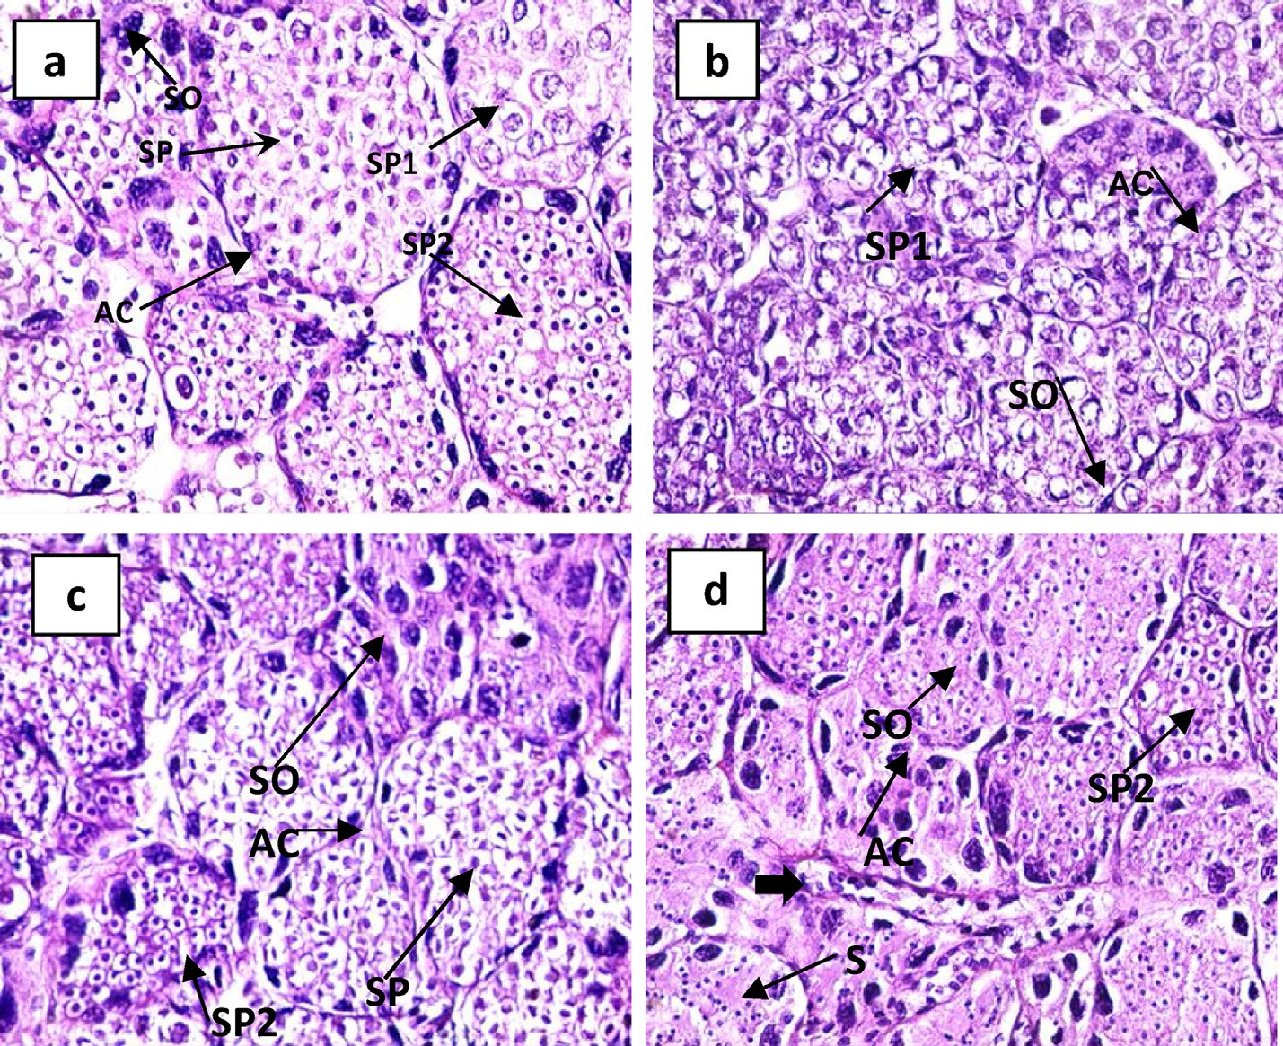

Fig. 2 e Light photomicrographs through testis of *P. clarkii* with sublethal concentration of *T. harzianum* stained with Haematoxylin and Eosin (one-week post exposure). (a): control showing normal structure of the testicular acini, spermatogonia, primary, secondary spermatocytes and spermatides, (b): showing closely packed (hyperplasia) with incomplete fusion between some testicular acini and disturbance in distribution of spermatogonia, (c): deformed architecture, disturbance in distributed of spermatogonia in some testicular acini, and (d): deformed architecture of some testicular acini and took elongated shape (solid arrow). Magnification; £ 400.

92 [e gypti an j o ur nal o f b a sic and a pp l i ed sci e n c e s 2 ( 201 5 ) 8 7](http://dx.doi.org/10.1016/j.ejbas.2015.02.001) e[9](http://dx.doi.org/10.1016/j.ejbas.2015.02.001) 7

e extracting buffer (Tris-buffer saline, 50 mM Tris-HCL, pH 7.5 containing 75 ml NaCl) intheratio 1:10 w/v[18]. Homogenization was carried out using glass road; Freezing-thawing method was

preformed to facilitate homogenization process. Centrifugation was carried out at 10000 g for 15 min at 4 ◦C. The pellet was discarded and a clear supernatant was collected. Tissue extracts weremixedin Ependorftubewithsamplebuffer(containing 10%

2 e mercabtoethanol) freshly added.

The protein bands were visualized by staining the gel with Coomassie Brilliant Blue (CBB) stain [19] and kept at room temperature until processed for photography.

### *Gel analysis*

Gel was analyzed using Gel pro analyzer software (ver.3.0) cypermedica USA and gel denistometer Bio-rad G-70, USA. The similarity of the polypeptide profile between the different groups was assessed from Dice similarity coefficient [20].

S = 2a/(2a + b + c) where, S: is the degree of identity, a: is the number of common shared bands in two compared samples, b: is the number of excess bands in the first compared sample and c: is the number of excess bands in the second compared sample.

An (S) value of 1.0 donates complete identify in the elec- trophoretic profile of both groups, while a value < 1.0 indicates a variation in the polypeptide profile between the two

compared sample.

# Results

* 1. *Tolerance effect of different concentrations of* T. harzianum *on* P. clarkii

The value of LC50 after 24, 48, 72 h and 20 days was 1.753, 1.445,

1.118 and 0.7809 ml/l, respectively. Where the value of LC90 after 24, 48, 72 h and 20 days was 2.042, 1.938, 1.748 and

1.6382 ml/l, respectively.

The toxic effects of the selected concentrations of *T. har- zianum* (20, 40, 50 and 100%) after 6 weeks of exposure were recorded in Table 1. Data revealed that tolerance period of *P. clarkii* to *T. harzianum* at concentration 20 and 40% was 39 and 28 days. However, at concentration 50%, *T. harzianum* toler- ance period was 26 days. At the concentration 100%, the tolerance period of *P. clarkii* was less than one day (20 h). The data indicated that the rate of mortality increased by increasing the concentration of *T. harzianum*.

### *Effect of sub-lethal concentration (20%) of* T. harzianum *on the electrophoretic patterns of muscles* proteins of P. Clarkii

a- Male

At the 1st week post exposure the electrophoretic analysis of protein in muscles of male *P. Clarkii* revealed 14 protein

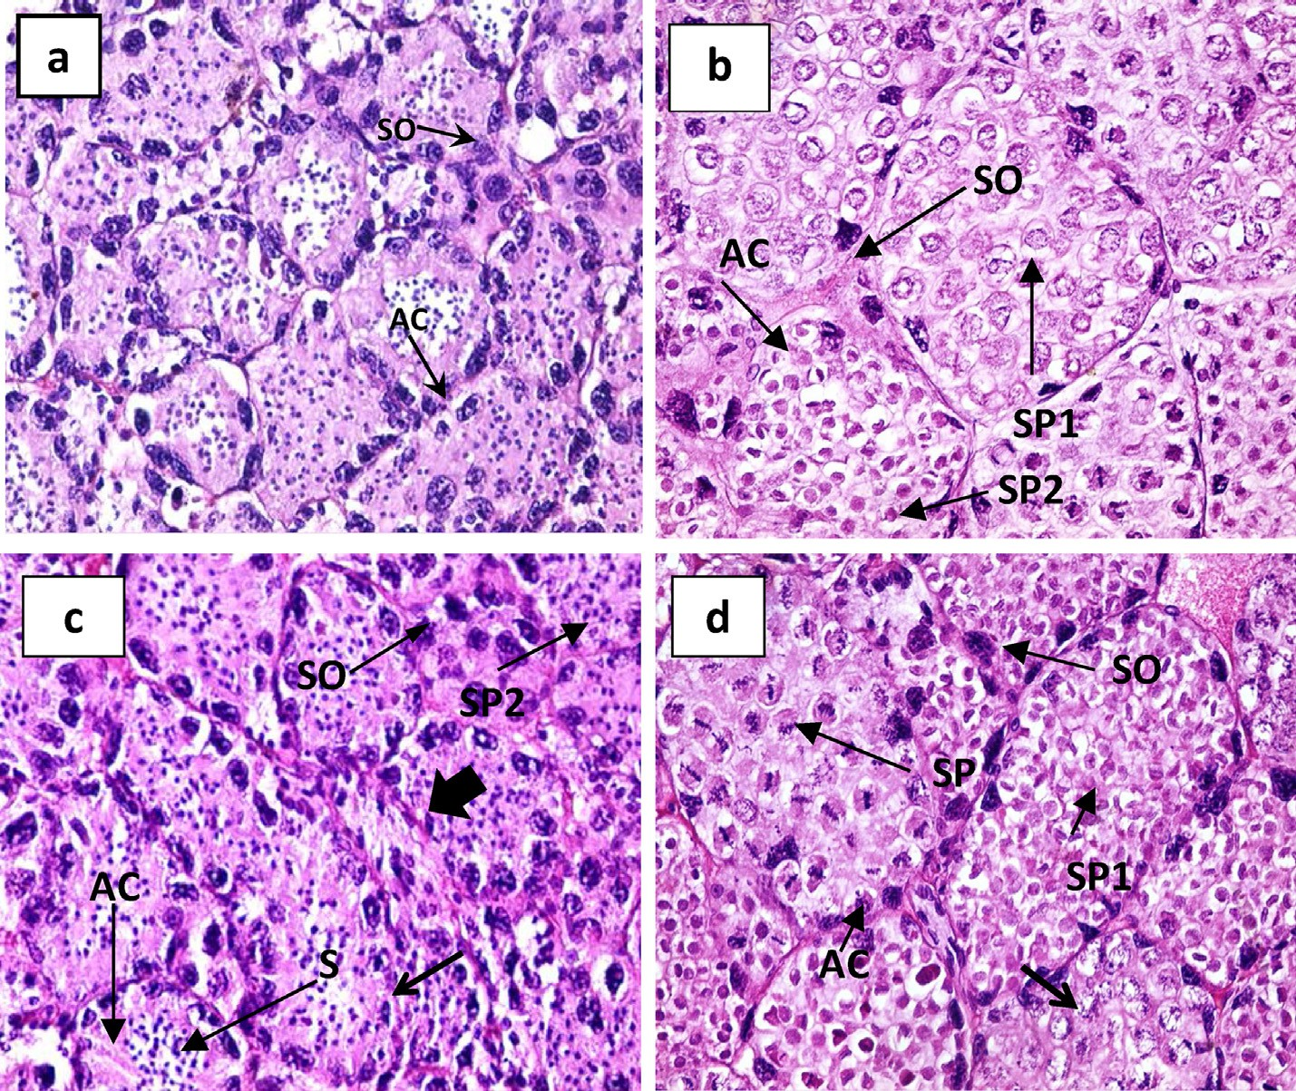

Fig. 3 e Light photomicrographs through testis of *P. clarkii* with sublethal concentration of *T. harzianum* stained with Haematoxylin and Eosin (two weeks post exposure). (a): control, (b): deformed architecture, closely packed (hyperplasia) incomplete fusion between some testicular acini, (c): deformed architecture with elongated shape testicular acini (solid arrow) and (d): Deformation of chromatin material in some testicular acini (arrow). Magnification; X 400.

[e g ypti an j o ur nal o f b a sic and a pp l i e d sci en c e s 2 ( 201 5 ) 8 7](http://dx.doi.org/10.1016/j.ejbas.2015.02.001) e[9](http://dx.doi.org/10.1016/j.ejbas.2015.02.001) 7 93

fractions of molecular weight between 10.09 and 278.70 kDa in non-treated (control). In the treated group, male *P. Clarkii* revealed 12 protein fractions of molecular weight between

15.67 and 275.60 kDa for one week. The similarity coefficient

“S” value was 0.154, as the treated group shared in 2 bands,

40.99 and 15.67 with non-treated *P. Clarkii* (Fig. 1 and Table 2). Electrophoratic analysis of protein muscles after 4 weeks of exposure yielded 14 bands ranging between 10.09 and

278.70 kDa in non-treated (Control) male *P. Clarkii* and revealed 15 protein fractions between 14.84 and 284.70 kDa in treated male *P. Clarkii*. The similarity coefficient “S” value was 0.207, as the treated group shared in 3 bands of 159.37, 30.95 and 14.84 kDa with non-treated *P. Clarkii* (Fig. 1 and Table 3).

b- Female

The effect of *T. harzianum* treatment on protein analysis showed quantitative difference in protein profiles. Protein electrophoretic analysis of female muscles yielded complex pattern of 15 bands ranging in molecular weight between

17.16 and 280.00 kDa in non-treated (Control) female *P. Clarkii*

in comparison to 14 bands ranged between 15.67 and

287.47 kDa in treated female *P. Clarkii* after one week of exposure. The bands 81.44 and 21.94 kDa shared the treated female with non-treated female. The similarity coefficient “S” value was 0.138, as the treated group characterized by pres- ence of 12 protein bands (Fig. 1 and Table 2).

Representative SDS-PAGE profiles of *T. harzianum* treated female *P. Clarkii* muscles protein at the 4th week post

exposure, illustrated in Fig. 1 and Table 3. Electrophoretic analysis of muscles protein gave up to19 bands ranged be- tween 15.25 and 282.70 kDa in treated female *P. Clarkii*. Where electrophoretic analysis of protein muscles in non- treated (Control) female *P. Clarkii* gave up 15 bands ranged between 17.16 and 280.00 kDa. The similarity coefficient “S” value was 0.35, as the treated group shared in 6 bands 100.20, 91.41, 42.65, 31.80, 28.95 and 23.22 kDa with non-treated female.

* 1. *Effect of sub-lethal concentration (20%) of* T*.* harzianum *on gonads of* P. clarkii

a- Male

The reproductive system of control male *P. clarkii* locates in the thoracic cavity above the digestive gland. The male reproductive system formed of two white milky testes each one consists of anterior and posterior portions.

The testis consists of numerous testicular acini, which are variable in size and shape. Each of them is surrounded by a basal lamina upon which the germinal epithelium rest. The stages of spermatogenesis are spermatogonia, primary sper- matocytes, secondary spermatocytes and spermatides, which pass to the collecting tubules. Spermatozoa pass to the vas deferens where they packed together in tubular spermato- phores in the vas deferense (Fig. 2a).

Treated testis showed deformed architecture, incomplete fusion between some testicular acini and disturbance in

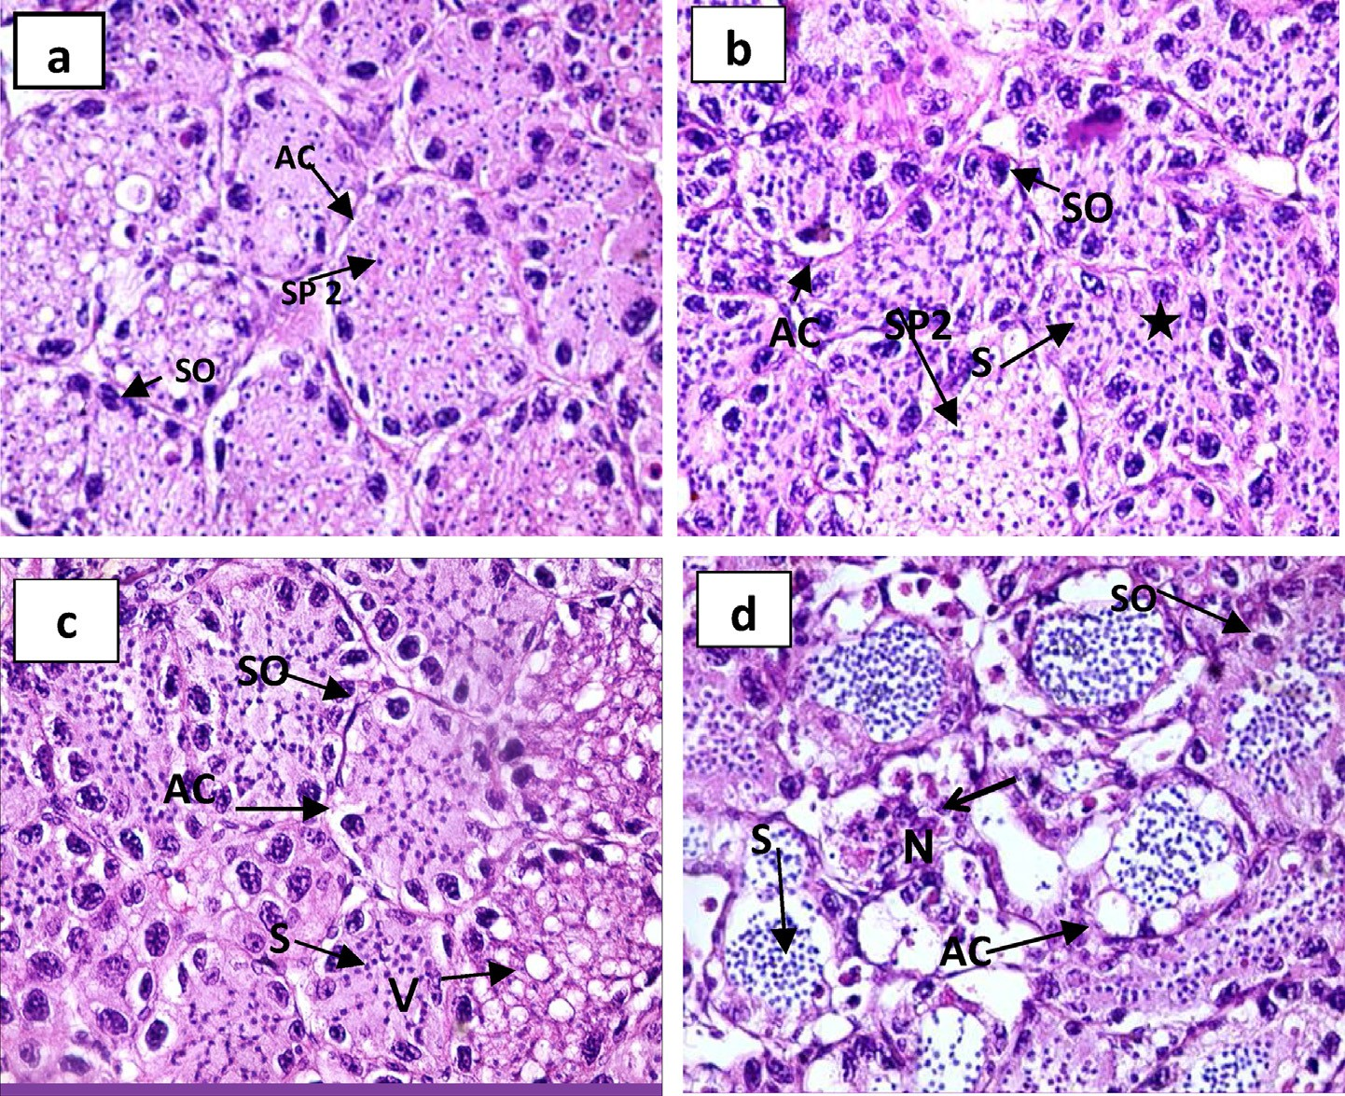

Fig. 4 e Light photomicrographs through testis of male *P. clarkii* with sublethal concentration of *T. harzianum* stained with Haematoxylin and Eosin (three weeks post exposure). (a): control, (b): deformed architecture with fusion of some testicular acini (star), (c): showing vacuoles inside primary spermatocytes and (d): showing necrotic tissue (arrow) in some testicular acini. Magnification; £400.

94 [e gypti an j o ur nal o f b a sic and a pp l i ed sci e n c e s 2 ( 201 5 ) 8 7](http://dx.doi.org/10.1016/j.ejbas.2015.02.001) e[9](http://dx.doi.org/10.1016/j.ejbas.2015.02.001) 7

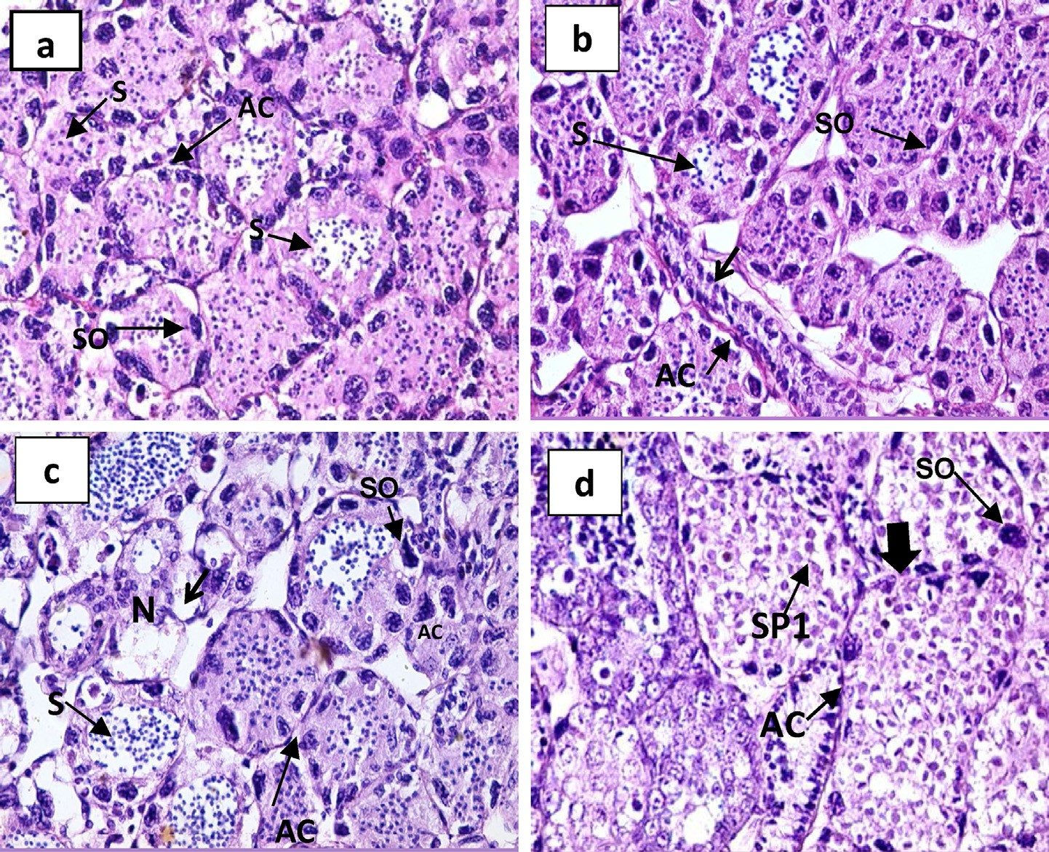

Fig. 5 e Light photomicrographs through testis of male *P. clarkii* with sublethal concentration of *T. harzianum* stained with Haematoxylin and Eosin (four weeks post exposure). (a) control, (b): deformed architecture of testicular acini (arrow) and fusion in some testicular acini, (c): showing deformed architecture with necrosis (arrow) of testicular acini and (d): showing deformed architecture with enlarged size of testicular acini (solid arrow). (AC): testicular acini, (SO): spermatogonia, (SP1): primary spermatocytes, (SP2): secondary spermatocytes, (SP): spermatides, (S): sperm, (N): necrosis and (V): vacuoles.

Magnification; £400.

distribution and number of spermatogonia. Necrosis in some testicular acini was recorded, and some appeared elongated/triangle in shape. Some vacuoles were observed inside primary spermatocytes and connective tissue showed some necrosis (Figs. 2e5).

b- Female

The reproductive system of control female *P. clarkii* demonstrating general construction of Y shaped ovary con- sisting of a pair of anterior ovarian sacs and a single median posterior one located in cephalothorax, dorsally to the stomach.

Histologically, the ovary consists of oogenetic pouch formed of the epithelium of the ovarian sacs. It is irregular intervals to form a number of oogenetic pouches of various size containing eggs or oocytes. Germarium is formed of special germ areas of the ovarian epithelium and located separately at the bases of well-developed oogenetic pouch throughout the ovary (Fig. 6a).

The treated ovary showed detachment between ovarian epithelium and oogenetic pouch. Also fusion between some of the oogenetic pouches, other oogenetic pouch enlarged in size and necrosis in connective tissue (Fig. 6).

# Discussion

* 1. *Tolerance effect of different concentrations of* T. harzianum *on* P. clarkii

The results of the current study showed remarkable reduction in the survival rate of *P. clarkii* treated with sub-lethal con- centrations of *T. harzianum*. The survival rate decreased by increasing the concentration during exposure periods. These results in agreement with the results of Abdul-Wahid *et al.*

[21] who reported that reduction of cockroaches' *(Periplaneta*

*americana)* population due to fungal treatment by *T. harzianum* was 100% at 24 h. Sakran [22] proved that Butachlor and fluazifop-p-butyl (herbicides) caused reduction in the survival rate of *Biomphalaria alexandrina*. Al-Assiuty *et al*. [23], show that the abundance and species diversity of oribatid mites varies greatly by the effect of fungicides (*T. harzianum* and *Pythium oligandrum*) by their taxon and fungicide. These effects are not due to direct toxicity of fungicides to the mites, but they are mediated by changes in the fungal community of the soil (as an essential food item for soil microarthropods). In addition, Stephan *et al*. [24] reported that *T. harzianum* gave the favorite results against growth and reproduction of root-knot

[e g ypti an j o ur nal o f b a sic and a pp l i e d sci en c e s 2 ( 201 5 ) 8 7](http://dx.doi.org/10.1016/j.ejbas.2015.02.001) e[9](http://dx.doi.org/10.1016/j.ejbas.2015.02.001) 7 95

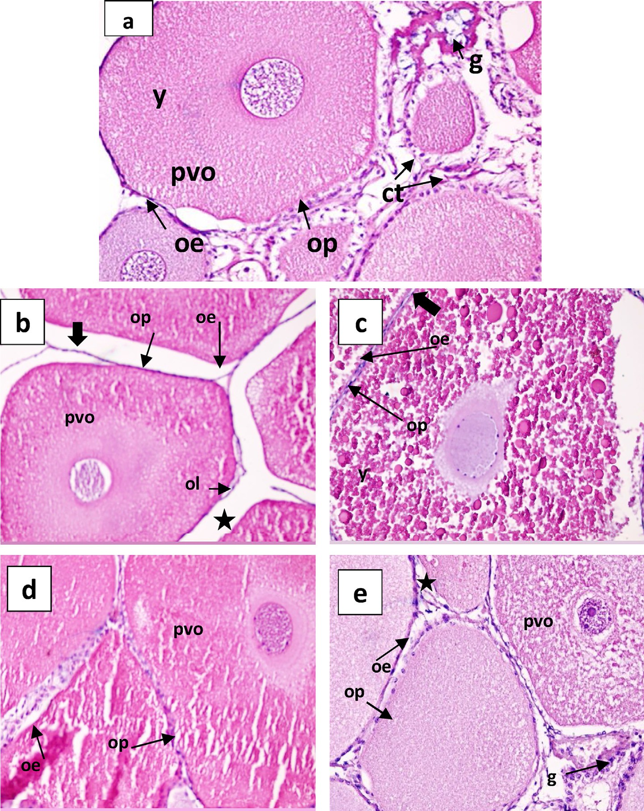

Fig. 6 e Light photomicrographs through ovary of female *P. clarkii* stained with Haematoxylin and Eosin. (a): control ovary showing oogenetic pouch, germarium, ovarian epithelium and Previtellognic oocyte, (b): treated ovary of female *P. clarkii* with sublethal concentration of *T. harzianum* showing necrosis in connective tissue (star) and detachment between ovarian epithelium and oogenetic pouch (solid arrow, one week post exposure), (c): showing fusion between oogenetic pouches. (solid arrow, two weeks post exposure), (d): showing enlargement in size of oogenetic pouch, (three weeks post exposure) and (e): showing necrosis in connective tissue (star, four weeks post exposure). (op): oogenetic pouch, (pvo): previtellognic oocyte, (oe): ovarian epithelium, (ct): connective tissue, (g): germarium and (y): yolk. Magnification; £200.

nematode (*Meloidogyne javanica*). In addition, Saifullah [25,26] recorded 100% mortality of the nematodes, *Globodera ros- tochien* and *Globodera pallida* by using poisoning compound from *T. harzianum* on the medium after 24 h of exposure. Di Pietro [27] explained the toxicity of *Trichoderma harazianum* that it producing several poisoning and antibiotic compounds. Lorito *et al*. [28] proved that *Trichoderma* includes chitinase enzyme, which considered the most effective component against pathogenic fungi. Chitinase enzymes degrade the fungal cell walls, which composed of chitin. Some of the most

important examples of biopesticides are toxins from microbial pesticides group as *Metarhizium anisopliae*'*s* streptozotocin. It was toxic to the shrimp (*Palaemonetes pugio*) when LC50 was 52 mg/l [29]. Another cause of mortality can be attributed to the blockage of fungi spores to the gills of *P. clarkii*, as what happened to the cockroaches; *Periplaneta americana* by Abdul- Wahid et al. [21].

The prolonged exposure of *P. clarkii* to sublethal concen- tration (20%) of *T. harzianum* showed differences in number of protein bands through the exposure period. Tolba *et al*.

96 [e gypti an j o ur nal o f b a sic and a pp l i ed sci e n c e s 2 ( 201 5 ) 8 7](http://dx.doi.org/10.1016/j.ejbas.2015.02.001) e[9](http://dx.doi.org/10.1016/j.ejbas.2015.02.001) 7

[30] stated that after exposure to a material, some factors

## r e f e r e n c e s

might increase or decrease depending on the compound

structure and its concentration, which causes disturbance in

functions of the internal organs, which might lead to alter- ations in protein fractions and metabolic process. Ibrahim *et al*. [31] recorded higher number of protein bands when *P. clarkii* exposed to different concentrations of heavy metals, which increased inside the tissues of the crayfish. This in- crease of protein might be due to synthesis of new poly- peptide chain, which acts as protective proteins against toxicity of heavy metals. Exposure of *Oreochromis niloticus* (fish) to Diclofop-methyl (herbicide) for 28 days resulted in some changes in plasma and muscles proteins. Electropho- retic protein pattern of the fish showed an increase of pro- tein bands of muscle while decrease in plasma proteins [32,33]. Glusczak *et al*. [34] indicated that when *Leporinus obtusidens* (fish) exposed to different concentrations of Roundup, lactates and proteins were decreased in plasma protein. Tilak *et al*. [35] indicated that fish exposed to some pesticides such as organochlorine, organophosphates and carbamates, caused depletion protein concentration in brain, gills, muscle, kidney and liver. In the kidney and the liver, there was evidence of significant decrease in the pro- tein content due to stress in metabolism. Chitin lytic effect of *T. harzianum* by penetrating the carapace of *P. clarkii* may be responsible for the decrease of protein bans at the beginning then the new synthesis of proteins increased the number of protein bands as a strategy to protect the animal to be susceptible.

Prolonged exposure of *P. clarkii* (male and female) to sub-

lethal concentration (20%) of *Trichoderma harizinum* showed severe damage of gonads. In testis and ovary of the treated *P. clarkii,* deformed architecture, necrosis in the testicular acini, ovarian follicles and connective tissue was recorded. Kim [36] proved that organochlorine, organophosphates and carba- mates caused morphological damage to the fish testis and affected female fish in the same way by causing delayed oocyte development and inhibition of steroid hormone syn- thesis. In addition, the biochemical changes caused by effects of pesticides lead to metabolic disturbances, inhibition of important enzymes, retardation of growth and reduction in the fecundity and longevity of the organism. Reynaldi and Liess [37] recorded that fenvalerate (insecticide) had great side effects on *Daphnia magna* when exposed to 0.3 mg/l for 21 days and caused greater adverse impact on reproductive rate. Srivastava *et al*. [38] recoded that, when freshwater snake- head fish, *Channa punctatus*, exposed to Devicyprin (a com- mercial insecticide formulation containing 25% cypermethrin), the gonad structure and development were altered and caused inflammation and intertubular vacuoli- zation of testis, while necrosis of testis tissues was evident after 30 days. The antifungal properties of purified chitino- lytic and glucanolytic enzymes (chitinase and glucanase) from the fungi *T. harzianum,* which cause cell wall lysing [39], could be a possible reason of histological alterations of *P. clarkii* gonads.

In conclusion, *T. harzianum* has deleterious effects on *P.*

*clarkii* and its productivity or even death to this organism, which is used as a cheap alternative protein source of prawns.

1. [Huner JV, Lindqvist OV. Physiological adaptations of](http://refhub.elsevier.com/S2314-808X(15)00014-7/sref1) [freshwater crayfishes that permit successful aquaculture](http://refhub.elsevier.com/S2314-808X(15)00014-7/sref1) [enterprises. Amer Zool 1995;35:12](http://refhub.elsevier.com/S2314-808X(15)00014-7/sref1)e[9](http://refhub.elsevier.com/S2314-808X(15)00014-7/sref1).
2. [Hobbs HH. An illustrated checklist of the American crayfish](http://refhub.elsevier.com/S2314-808X(15)00014-7/sref2) [(Decapoda: Astacidae, Cambaridae and Parastacidae).](http://refhub.elsevier.com/S2314-808X(15)00014-7/sref2) [Smithsonian Contributions to Zoology. Washington, DC:](http://refhub.elsevier.com/S2314-808X(15)00014-7/sref2) [Smithsonian Institute Press; 1989](http://refhub.elsevier.com/S2314-808X(15)00014-7/sref2).
3. [Henttonen P, Huner JV. The introduction of alien species of](http://refhub.elsevier.com/S2314-808X(15)00014-7/sref3) [crayfish in Europe: a historical introduction. In: Gherardi F,](http://refhub.elsevier.com/S2314-808X(15)00014-7/sref3) [Holdich DM, editors. Crayfish in Europe as Alien species.](http://refhub.elsevier.com/S2314-808X(15)00014-7/sref3) [Balkema AA, editor. Crustacean issues, 11; 1999. p. 13](http://refhub.elsevier.com/S2314-808X(15)00014-7/sref3)e[22.](http://refhub.elsevier.com/S2314-808X(15)00014-7/sref3) [Rotterdam: Netherlands](http://refhub.elsevier.com/S2314-808X(15)00014-7/sref3).
4. [Huner JV. Overview of international and domestic freshwater](http://refhub.elsevier.com/S2314-808X(15)00014-7/sref4) [crawfish production. J Shellfish Res 1989;5:259](http://refhub.elsevier.com/S2314-808X(15)00014-7/sref4)e[66](http://refhub.elsevier.com/S2314-808X(15)00014-7/sref4).
5. [Huner JV, Moody M, Thune R. Cultivation of freshwater](http://refhub.elsevier.com/S2314-808X(15)00014-7/sref5) [crayfishes in North America. In: Huner JV, editor. Freshwater](http://refhub.elsevier.com/S2314-808X(15)00014-7/sref5) [crayfish aquaculture in North America, Europe and Australia.](http://refhub.elsevier.com/S2314-808X(15)00014-7/sref5) [Families Astacidae, Cambaridae and Parastacidae. New York:](http://refhub.elsevier.com/S2314-808X(15)00014-7/sref5) [Haworth Press; 1993. p. 5](http://refhub.elsevier.com/S2314-808X(15)00014-7/sref5)e[136](http://refhub.elsevier.com/S2314-808X(15)00014-7/sref5).
6. [Sommer TR, Goldman CR. The crayfish *Procambarus clarkii*](http://refhub.elsevier.com/S2314-808X(15)00014-7/sref6)[from California rice fields: ecology, problems and potential](http://refhub.elsevier.com/S2314-808X(15)00014-7/sref6) [for harvest. Freshw Crayfish 1983;5:418](http://refhub.elsevier.com/S2314-808X(15)00014-7/sref6)e[28](http://refhub.elsevier.com/S2314-808X(15)00014-7/sref6).
7. [Ibrahim AM, Khalil MT. The red swamp crayfish in Egypt.](http://refhub.elsevier.com/S2314-808X(15)00014-7/sref7) [Center of Research and Studies of Protectorates, Ain Shams](http://refhub.elsevier.com/S2314-808X(15)00014-7/sref7) [University; 2009. p. 1](http://refhub.elsevier.com/S2314-808X(15)00014-7/sref7)e[136](http://refhub.elsevier.com/S2314-808X(15)00014-7/sref7).
8. [Pollard JE, Melancon SM, Blakey LS. Importance of](http://refhub.elsevier.com/S2314-808X(15)00014-7/sref8) [bottomland hardwoods to crawfish and fish in the](http://refhub.elsevier.com/S2314-808X(15)00014-7/sref8) [Henderson Lake Area, Atchafalaya Basin, Louisiana.](http://refhub.elsevier.com/S2314-808X(15)00014-7/sref8) [Wetlands 1983;3:1](http://refhub.elsevier.com/S2314-808X(15)00014-7/sref8)e[25](http://refhub.elsevier.com/S2314-808X(15)00014-7/sref8).
9. [Anderson MB, Reddy P, Preslan JE, Fingerman M, Bollinger J,](http://refhub.elsevier.com/S2314-808X(15)00014-7/sref9) [Jolibois L, et al. Metal accumulation in crayfish, *Procambarus*](http://refhub.elsevier.com/S2314-808X(15)00014-7/sref9)[*clarkii* exposed to petroleum- contaminated Bayou in](http://refhub.elsevier.com/S2314-808X(15)00014-7/sref9) [Louisiana. J Ecotox Environ Saf 1997;37(3):267](http://refhub.elsevier.com/S2314-808X(15)00014-7/sref9)e[72](http://refhub.elsevier.com/S2314-808X(15)00014-7/sref9).
10. [Ibrahim AM, Emam WM, Abdel-Rahman S. Ridding of](http://refhub.elsevier.com/S2314-808X(15)00014-7/sref10) [undesirable crayfish *Procambarus clarkii* from certain habitat](http://refhub.elsevier.com/S2314-808X(15)00014-7/sref10) [in Egypt by means of organophosphorus insecticide. J Egypt](http://refhub.elsevier.com/S2314-808X(15)00014-7/sref10) [Acad Soc Environ Dev 2005;6(2):267](http://refhub.elsevier.com/S2314-808X(15)00014-7/sref10)e[76](http://refhub.elsevier.com/S2314-808X(15)00014-7/sref10).
11. [Abdel Mageed ZAY. Biochemical and biological studies on](http://refhub.elsevier.com/S2314-808X(15)00014-7/sref11) [*Procambarus clarkii* (Girard, 1852) from Egypt. Ph. D. Thesis.](http://refhub.elsevier.com/S2314-808X(15)00014-7/sref11) [Helwan University; 2004. p. 236](http://refhub.elsevier.com/S2314-808X(15)00014-7/sref11).
12. [Heiba FN. Effects of g-irradiation on the gametogenesis of](http://refhub.elsevier.com/S2314-808X(15)00014-7/sref12) [the freshwater crayfish *Procambarus clark*ii (Girard, 1852).](http://refhub.elsevier.com/S2314-808X(15)00014-7/sref12) [Egypt J Aquat Biol Fish 1998;2(4):29](http://refhub.elsevier.com/S2314-808X(15)00014-7/sref12)e[34](http://refhub.elsevier.com/S2314-808X(15)00014-7/sref12).
13. [Rouabhi R. Introduction and toxicology of fungicides.](http://refhub.elsevier.com/S2314-808X(15)00014-7/sref13) [Fungicides 2010;18:363](http://refhub.elsevier.com/S2314-808X(15)00014-7/sref13)e[82](http://refhub.elsevier.com/S2314-808X(15)00014-7/sref13).
14. [Martı´nez-Medina A, Alguacil MDM, Pascual JA, Van](http://refhub.elsevier.com/S2314-808X(15)00014-7/sref14)

[Wees SCM. Phytohormone profiles induced by trichoderma](http://refhub.elsevier.com/S2314-808X(15)00014-7/sref14) [isolates correspond with their biocontrol and plant growth-](http://refhub.elsevier.com/S2314-808X(15)00014-7/sref14) [promoting activity on melon plants. J Chem Ecol](http://refhub.elsevier.com/S2314-808X(15)00014-7/sref14) [2014;40:804](http://refhub.elsevier.com/S2314-808X(15)00014-7/sref14)e[15](http://refhub.elsevier.com/S2314-808X(15)00014-7/sref14).

1. [WHO. Molluscicide screening and evaluation. Bull WHO](http://refhub.elsevier.com/S2314-808X(15)00014-7/sref15) [1965;83:567](http://refhub.elsevier.com/S2314-808X(15)00014-7/sref15)e[81](http://refhub.elsevier.com/S2314-808X(15)00014-7/sref15).
2. [Romeis B. Mikroskopische Technik. Auflage, Urban and](http://refhub.elsevier.com/S2314-808X(15)00014-7/sref16) [Schwarzenberg, Munchen-Wien-Baltimore, 17; 1989.](http://refhub.elsevier.com/S2314-808X(15)00014-7/sref16)

[p. 235](http://refhub.elsevier.com/S2314-808X(15)00014-7/sref16)e[6](http://refhub.elsevier.com/S2314-808X(15)00014-7/sref16).

1. [Boswell CA, Yoshino TP, Dumm TS. Analysis of tegumental](http://refhub.elsevier.com/S2314-808X(15)00014-7/sref17) [surface proteins of *S. mansoini* primary sporocysts. J Parasitol](http://refhub.elsevier.com/S2314-808X(15)00014-7/sref17) [1987;73:778](http://refhub.elsevier.com/S2314-808X(15)00014-7/sref17)e[86](http://refhub.elsevier.com/S2314-808X(15)00014-7/sref17).
2. [Bradford MM. A rapid and sensitive method for quantitation](http://refhub.elsevier.com/S2314-808X(15)00014-7/sref18) [of microgram quantities of protein utilizing the principle of](http://refhub.elsevier.com/S2314-808X(15)00014-7/sref18) [protein binding. Anal Biochem 1976;72:248](http://refhub.elsevier.com/S2314-808X(15)00014-7/sref18)e[54](http://refhub.elsevier.com/S2314-808X(15)00014-7/sref18).
3. [De-Moreno MR, Smith JF, Smith RV. Silver staining of](http://refhub.elsevier.com/S2314-808X(15)00014-7/sref19) [proteins in polycrylamide gels: increased sensitivity through](http://refhub.elsevier.com/S2314-808X(15)00014-7/sref19) [a combined Coomassie Blue silver stain procedure. Anal](http://refhub.elsevier.com/S2314-808X(15)00014-7/sref19) [Biochem 1985;126:466](http://refhub.elsevier.com/S2314-808X(15)00014-7/sref19)e[70](http://refhub.elsevier.com/S2314-808X(15)00014-7/sref19).

[e g ypti an j o ur nal o f b a sic and a pp l i e d sci en c e s 2 ( 201 5 ) 8 7](http://dx.doi.org/10.1016/j.ejbas.2015.02.001) e[9](http://dx.doi.org/10.1016/j.ejbas.2015.02.001) 7 97

1. [Dice LR. Measures of the amount of ecological association](http://refhub.elsevier.com/S2314-808X(15)00014-7/sref20) [between species. Ecology 1945;26:297](http://refhub.elsevier.com/S2314-808X(15)00014-7/sref20)e[302](http://refhub.elsevier.com/S2314-808X(15)00014-7/sref20).
2. [Abdul-Wahid OA, Elbanna SM. Evaluation of the insecticidal](http://refhub.elsevier.com/S2314-808X(15)00014-7/sref21) [activity of *Fusarium solani* and *Trichoderma harzianum* against](http://refhub.elsevier.com/S2314-808X(15)00014-7/sref21) [cockroaches; *Periplaneta Americana*. Afr J Microbiol Res](http://refhub.elsevier.com/S2314-808X(15)00014-7/sref21) [2012;6(5):1024](http://refhub.elsevier.com/S2314-808X(15)00014-7/sref21)e[32](http://refhub.elsevier.com/S2314-808X(15)00014-7/sref21).
3. [Sakran AMA. Biological and physiological studies on](http://refhub.elsevier.com/S2314-808X(15)00014-7/sref22) [*Biomphalaria alexandrina* snails exposed to two herbicides.](http://refhub.elsevier.com/S2314-808X(15)00014-7/sref22) [Egypt J Zool 2004;42:205](http://refhub.elsevier.com/S2314-808X(15)00014-7/sref22)e[15](http://refhub.elsevier.com/S2314-808X(15)00014-7/sref22).
4. [Al-Assiuty AIM, Khalil MA, Ismail AA, Van Straalen NM,](http://refhub.elsevier.com/S2314-808X(15)00014-7/sref23) [Ageba MF. Effects of fungicides and biofungicides on](http://refhub.elsevier.com/S2314-808X(15)00014-7/sref23) [population density and community structure of soil oribatid](http://refhub.elsevier.com/S2314-808X(15)00014-7/sref23) [mites. Sci Total Environ 2014:412](http://refhub.elsevier.com/S2314-808X(15)00014-7/sref23)e[20](http://refhub.elsevier.com/S2314-808X(15)00014-7/sref23).
5. [Stephan ZA, El-Behadli AH, Al-Zahroon HH, Antoon BG,](http://refhub.elsevier.com/S2314-808X(15)00014-7/sref24) [Georgees SSH. Control of root-knot](http://refhub.elsevier.com/S2314-808X(15)00014-7/sref24) e [wilt disease complex](http://refhub.elsevier.com/S2314-808X(15)00014-7/sref24) [on tomato plants. Dirasat Agric Sci 1996;23:13](http://refhub.elsevier.com/S2314-808X(15)00014-7/sref24)e[6](http://refhub.elsevier.com/S2314-808X(15)00014-7/sref24).
6. [Saifullah SM. Fungal parasitism of young females of](http://refhub.elsevier.com/S2314-808X(15)00014-7/sref25) [*Globodera rostochiensis* and Pallida. Afro-Asian J Nematol](http://refhub.elsevier.com/S2314-808X(15)00014-7/sref25) [1996a;6:17](http://refhub.elsevier.com/S2314-808X(15)00014-7/sref25)e[22](http://refhub.elsevier.com/S2314-808X(15)00014-7/sref25).
7. [Saifullah SM. Killing potato cyst nematode males: a possible](http://refhub.elsevier.com/S2314-808X(15)00014-7/sref26) [control strategy. Afro-Asian J Nematol 1996b;6:23](http://refhub.elsevier.com/S2314-808X(15)00014-7/sref26)e[8](http://refhub.elsevier.com/S2314-808X(15)00014-7/sref26).
8. [Di Pietro A. Fungal antibioses in biocontrol of plant disease.](http://refhub.elsevier.com/S2314-808X(15)00014-7/sref27) [In: Allelopathy: organisms processes and applications.](http://refhub.elsevier.com/S2314-808X(15)00014-7/sref27) [Dakshini; 1995. p. 271](http://refhub.elsevier.com/S2314-808X(15)00014-7/sref27)e[9](http://refhub.elsevier.com/S2314-808X(15)00014-7/sref27).
9. [Lorito MG, Harman E, Hayes CK, Broadway RM, Tronsmo A,](http://refhub.elsevier.com/S2314-808X(15)00014-7/sref28) [Woo SI, et al. Chitinolytic enzymes produced by *Trichoderma*](http://refhub.elsevier.com/S2314-808X(15)00014-7/sref28)[*harzianum*. Phytopathology 1993;863:302](http://refhub.elsevier.com/S2314-808X(15)00014-7/sref28)e[7](http://refhub.elsevier.com/S2314-808X(15)00014-7/sref28).
10. [Genthner FJ, Chancy CA, Couch JA. Toxicity and](http://refhub.elsevier.com/S2314-808X(15)00014-7/sref29) [pathogenicity testing of the insect pest control fungus](http://refhub.elsevier.com/S2314-808X(15)00014-7/sref29) [*Metarrhizium anisop liae*. Archi Environ Contamin Toxicol](http://refhub.elsevier.com/S2314-808X(15)00014-7/sref29) [1998;35:317](http://refhub.elsevier.com/S2314-808X(15)00014-7/sref29)e[24](http://refhub.elsevier.com/S2314-808X(15)00014-7/sref29).
11. [Tolba MR, Mohamed B, Mohamed M. Effect of some heavy](http://refhub.elsevier.com/S2314-808X(15)00014-7/sref30) [metals on respiration, mean enzyme activity and total](http://refhub.elsevier.com/S2314-808X(15)00014-7/sref30) [protein of pulmonate snails *B. alexandrina* and *B. truncatus*](http://refhub.elsevier.com/S2314-808X(15)00014-7/sref30). J [Egypt Ger Soc Zool 1997;24(D):17](http://refhub.elsevier.com/S2314-808X(15)00014-7/sref30)e[35](http://refhub.elsevier.com/S2314-808X(15)00014-7/sref30).
12. [Ibrahim AM, Emam WM, Fakhry FM, Rifai A, Abd-El](http://refhub.elsevier.com/S2314-808X(15)00014-7/sref31) [Rahman AS. Toxicity and bioaccumulation of some heavy](http://refhub.elsevier.com/S2314-808X(15)00014-7/sref31) [metals in the crayfish *Procambarus clarkii* from the River Nile,](http://refhub.elsevier.com/S2314-808X(15)00014-7/sref31) [Egypt. J Egypt Acad Soc Environ Dev (D-Environ Stud)](http://refhub.elsevier.com/S2314-808X(15)00014-7/sref31) [2006;7(2):131](http://refhub.elsevier.com/S2314-808X(15)00014-7/sref31)e[58](http://refhub.elsevier.com/S2314-808X(15)00014-7/sref31).
13. [Rashed MA, Ibrahim SA, El-Saeoudy AA, Abd-El-Tawab FM,](http://refhub.elsevier.com/S2314-808X(15)00014-7/sref32) [Ahmed GE. Effect of pollutant with organophosphorus](http://refhub.elsevier.com/S2314-808X(15)00014-7/sref32) [insecticide (Tamaron) in muscle protein electrophoresis to](http://refhub.elsevier.com/S2314-808X(15)00014-7/sref32) [some *Tilapia* species. Egypt J Appl Sci 1992;7:497](http://refhub.elsevier.com/S2314-808X(15)00014-7/sref32)e[510](http://refhub.elsevier.com/S2314-808X(15)00014-7/sref32).
14. [Gamila KAM, Sherif AH, Ahmed FAGh, Manal EEA. Multi-](http://refhub.elsevier.com/S2314-808X(15)00014-7/sref33) [biomarker responses to bioaccumulation of diclofop-methyl](http://refhub.elsevier.com/S2314-808X(15)00014-7/sref33) [in freshwater fish (*Oreochromis niloticus*). Egypt J Histol Medic](http://refhub.elsevier.com/S2314-808X(15)00014-7/sref33) [2010;40:435](http://refhub.elsevier.com/S2314-808X(15)00014-7/sref33)e[48](http://refhub.elsevier.com/S2314-808X(15)00014-7/sref33).
15. [Glusczak L, Miron dos Santos D, Crestani M, Da Fonseca BM,](http://refhub.elsevier.com/S2314-808X(15)00014-7/sref34) [Pedron De Araujo F, Duarte MF, et al. Effect of glyphosate](http://refhub.elsevier.com/S2314-808X(15)00014-7/sref34) [herbicide on acetylcholinesterase activity and metabolic and](http://refhub.elsevier.com/S2314-808X(15)00014-7/sref34) [hematogical parameters in piava (*Leporinus obtusidens*).](http://refhub.elsevier.com/S2314-808X(15)00014-7/sref34) [Ecotoxicol Environ Saf 2006;65:237](http://refhub.elsevier.com/S2314-808X(15)00014-7/sref34)e[41](http://refhub.elsevier.com/S2314-808X(15)00014-7/sref34).
16. [Tilak KS, Janardhana Rao NH, Lakshmi J. Effect of pesticides](http://refhub.elsevier.com/S2314-808X(15)00014-7/sref35) [mixed in different ratios to the freshwater *Lareo rohita*](http://refhub.elsevier.com/S2314-808X(15)00014-7/sref35). J [Ecotoxicol Environ Monit 1991;1:49](http://refhub.elsevier.com/S2314-808X(15)00014-7/sref35)e[52](http://refhub.elsevier.com/S2314-808X(15)00014-7/sref35).
17. [Kim DE. Endocrine disruption in fish. London: Kluwer](http://refhub.elsevier.com/S2314-808X(15)00014-7/sref36) [Academic Publishers; 1998](http://refhub.elsevier.com/S2314-808X(15)00014-7/sref36).
18. [Reynaldi S, Liess M. Influence of duration of exposure to the](http://refhub.elsevier.com/S2314-808X(15)00014-7/sref37) [pyrethroid fenvalerate on sublethal responses and recovery](http://refhub.elsevier.com/S2314-808X(15)00014-7/sref37) [of *Daphnia magna* straus. Environ Toxicol Chem](http://refhub.elsevier.com/S2314-808X(15)00014-7/sref37) [2005;24:1160](http://refhub.elsevier.com/S2314-808X(15)00014-7/sref37)e[4](http://refhub.elsevier.com/S2314-808X(15)00014-7/sref37).
19. [Srivastava RK, Yadav KK, Trived SP. Devicyprin induced](http://refhub.elsevier.com/S2314-808X(15)00014-7/sref38) [gonadal impairment in a freshwater food fish, *Channa*](http://refhub.elsevier.com/S2314-808X(15)00014-7/sref38)[*punctatus* (Bloch). J Environ Biol 2008;29:187](http://refhub.elsevier.com/S2314-808X(15)00014-7/sref38)e[91](http://refhub.elsevier.com/S2314-808X(15)00014-7/sref38).
20. [Viterbo A, Ramot O, Chernin L, Chet I. Significance of lytic](http://refhub.elsevier.com/S2314-808X(15)00014-7/sref39) [enzymes from *Trichoderma* spp. in the biocontrol of fungal](http://refhub.elsevier.com/S2314-808X(15)00014-7/sref39) [plant pathogens. Antonie Leeuwenhoek 2002;81:549](http://refhub.elsevier.com/S2314-808X(15)00014-7/sref39)e[56](http://refhub.elsevier.com/S2314-808X(15)00014-7/sref39).